Algebra 1B Name: ____________________________
Unit 2 Practice Day
Worksheet

Directions: Calculate the slope of the lines with the given information.
Connects points (-2, 5) & (6, -3) Perpendicular to the slope $m=\frac{1}{8}$

slope = __________ slope = __________ slope = __________

Directions: Sketch the graphs of the following equations.
$y=\frac{2}{7}x−4$ $3x−6y=\text{12}$ $y−3x=5$
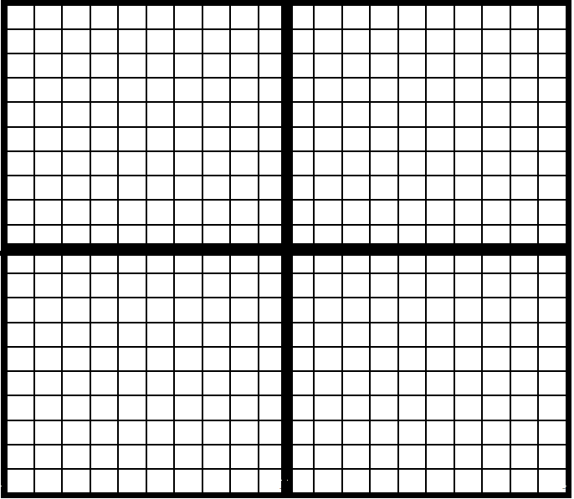

Directions: Write the equations of the lines in the indicated form.
Goes through the points (4, 1) & (3, -6) Parallel to $y=\frac{1}{2}x−6$through the point (2, -4)

_____________________ _____________________ _____________________
(Slope-Intercept Form) (Standard Form) (Slope-Intercept Form)

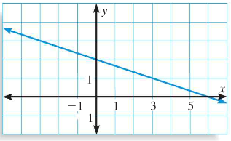

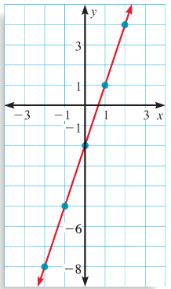

Directions: Determine if the following represent functions or relations by circling your answer.

Function Function Function
OR OR OR
Relation Relation Relation

Directions: Evaluate the following functions.
$f(x)=x^{2}−5x$ $f(2)=$_______ $f(x)=4−3x$ $f(−4)=$_______ $f(x)=\frac{x+2}{2x−1}$ $f(1)=$_______
Directions: Complete the following.
- Plot the data values on the graph:

x | y
1 | 8
2 | 7
4 | 7
5 | 6
6 | 4
7 | 5
9 | 5

- Draw the line of best fit

- Write the equation of the line in slope-intercept form: _________________________

